**Stakeholders Chart**

*Project Stakeholder Management*

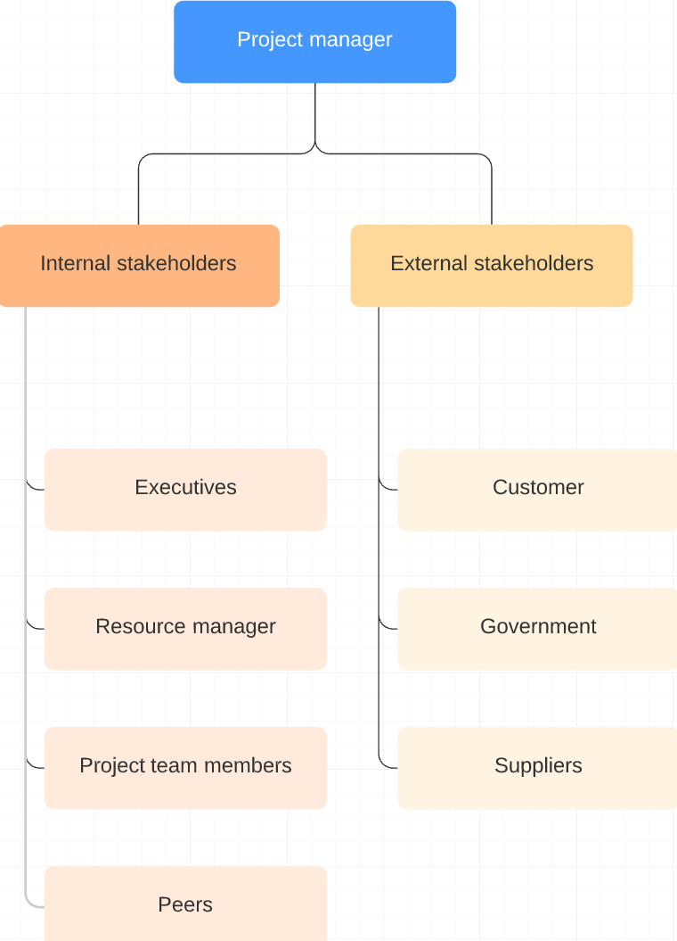

The stakeholders on this project require specific management strategies applied to their roles. Executives such as the company president, vice-presidents, directors, and division managers are responsible for directing company strategy and approving project plans. An appropriate reporting methodology should be employed to inform executive management on project milestones and risks.

The project may need the team to pull resources from surrounding teams. Building strong relationships with other managers in charge of resources is crucial to orchestrating the necessary inflow of project staff.

Project team members take direction from the project manager as they accomplish their committed tasks. Some team members may be juggling other responsibilities at the time of the project and also may conflict with management’s leadership style. By keeping engagement high throughout project planning and execution as well as meeting with team members one-on-one to hear feedback and concerns, members with multiple priorities can be better led.

Peers are individuals within the company who have a vested interest in the project’s outcome and may or may not be on the team. They do not carry the leadership responsibility for project success or failure. Personality or technical conflicts may arise from peers. Review meetings should be conducted often and management should ask directly for full support from peers.

As for external stakeholders, the customer represents various businesses that may use the API. The businesses themselves are likely overseen by government regulators and require project activities to be documented by the API in specific ways, adhering to legal obligations. If customizations are requested by businesses, a later version of the API would need to address them. Lastly, the project relies on suppliers of blockchain and cloud technology to support the API. If issues arise that can not be resolved within their platforms, then the project will have to utilize other providers.